Lab 14 Report

1. **Single-Source Shortest-Path Problem：**

**Given as input a weighted graph, G = ( V, E ), and a** **distinguished vertex, s, find the** **shortest weighted path from s to every other vertex in G.**

**1.1 Populate the graph representation：**

I use the double dictionary to simulate the function of the multiple lists, and the weighted graph is given in the question.

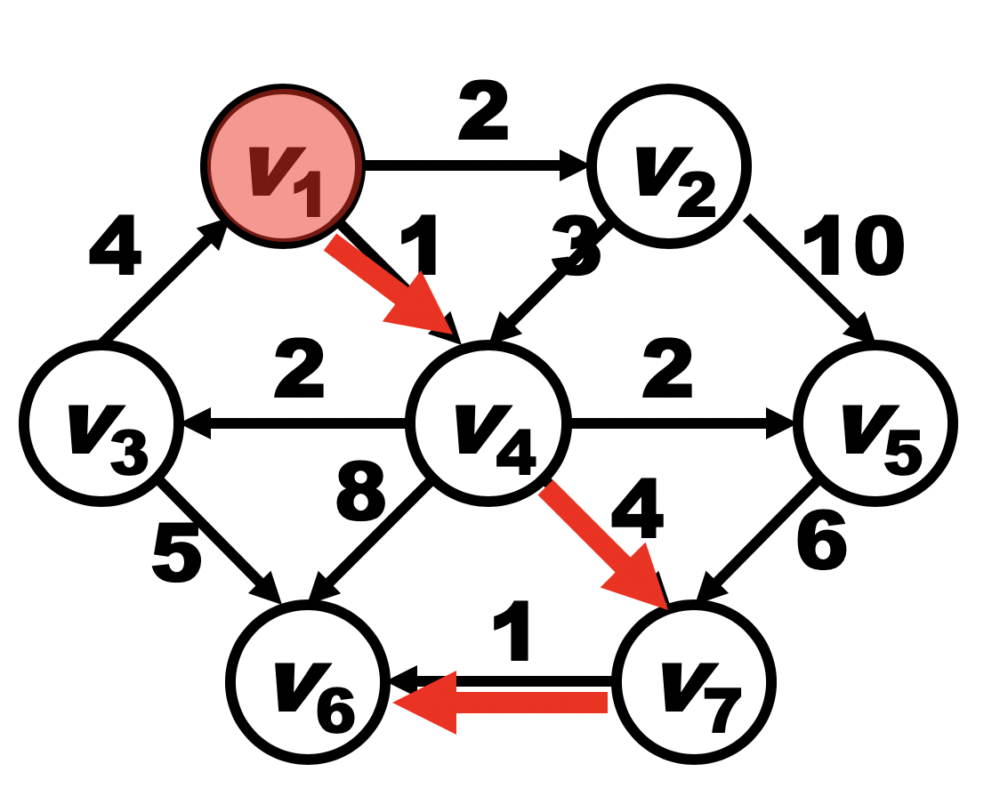

Code:

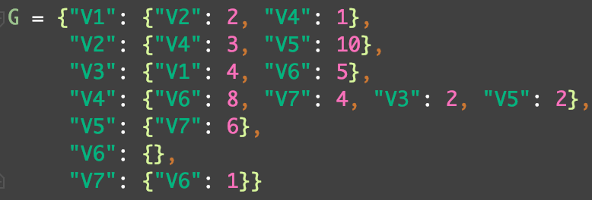

**1.2 Work and print out the paths.**

To get the shortest weighted path from ***s*** to every other vertex in G, where the ***s*** is given as V1, I used the Dijkstra’s method. It tries to find the min-cost path of every small sub-path in the whole path from ***s*** to the vertex to find the min-cost path form ***s*** to the vertex.

Code:

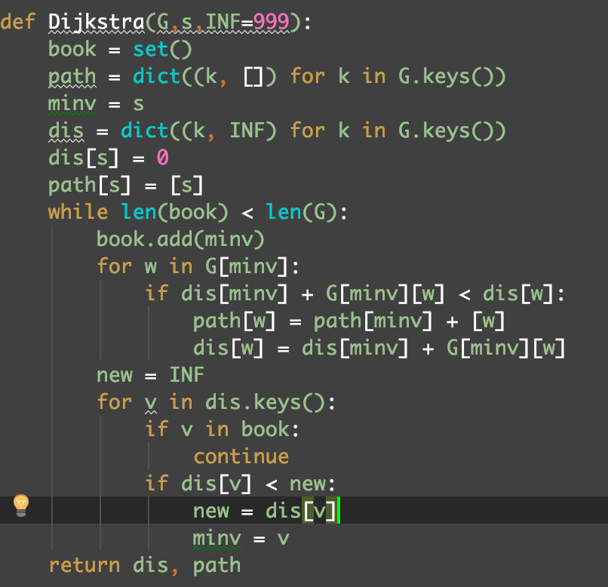

In this function, the ***G*** is the graph while the ***s*** is the distinguished vertex. The output ***dis*** is a dictionary, whose ***keys*** are the vertexes and the relative ***values*** is the shortest weighted path from ***s*** to every other vertex in ***G***. The output ***path*** has the ***same keys*** but the ***values*** are the relevant paths.

**Test:**

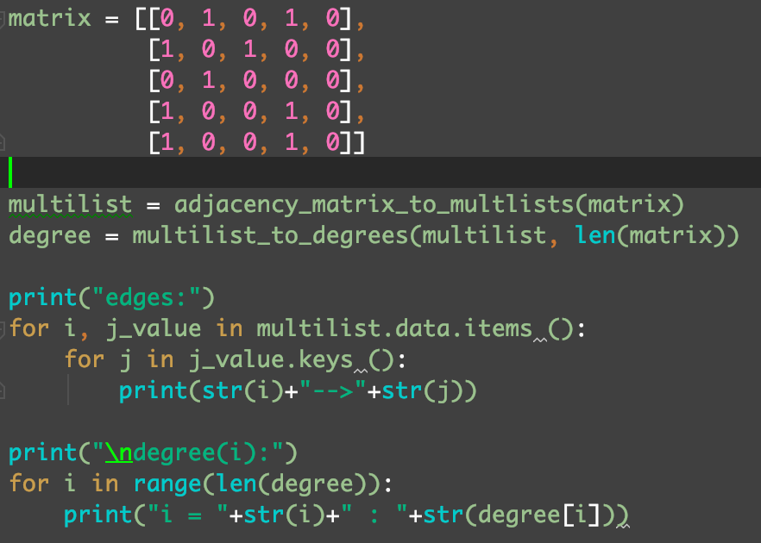

**Output:**

